# Select Queries

## Write 8 select queries to query the data that you have included in your tables

#1

select BranchID, BranchName, B_CountryID

from branch

where BranchID=1;

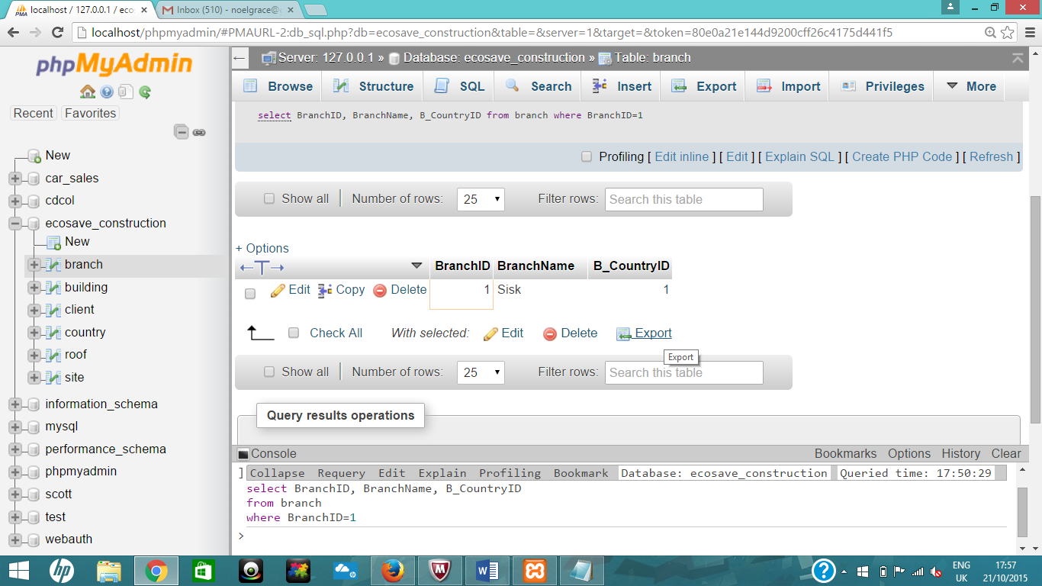

#2

select BuildingType, BuildingHeight

from building

WHERE

BuildingHeight >= 50;

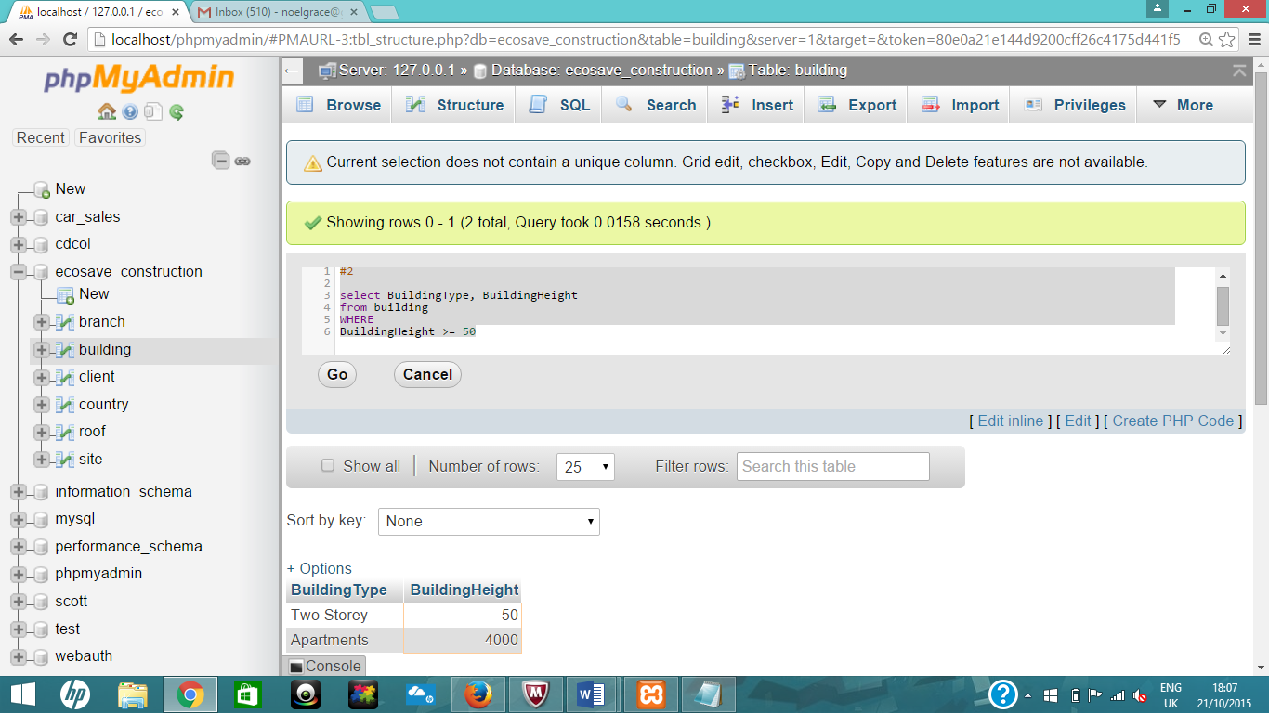

#3

select ClientName, ClientAddress

from client

where ClientAddress like 'Tinn%';

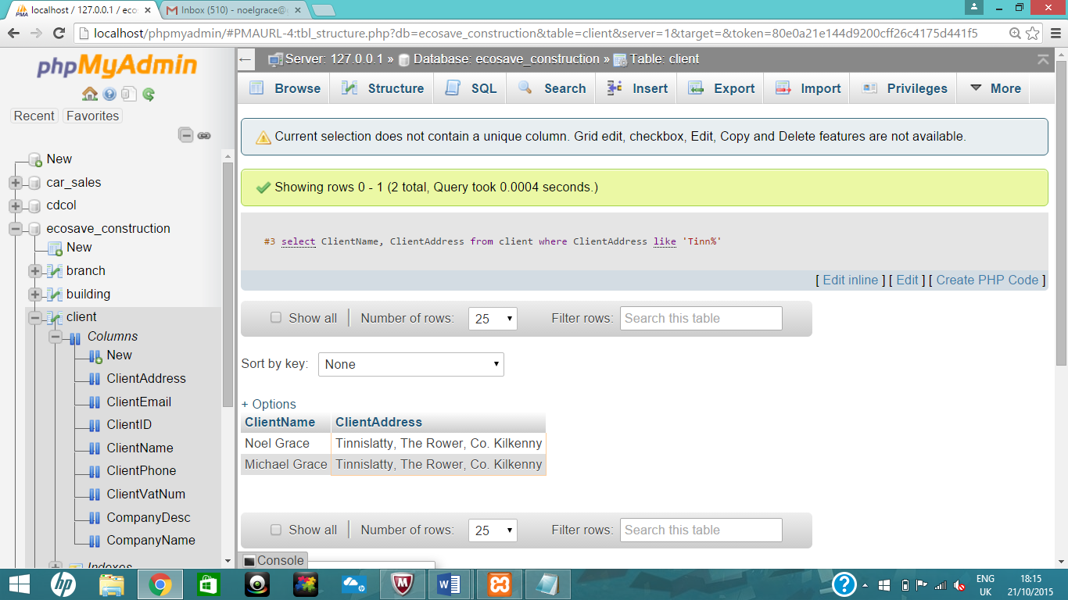

#4

select RoofType, RoofAngle, RoofSoilDepth

from roof

ORDER BY `roof`.`RoofAngle` ASC, RoofSoilDepth desc;

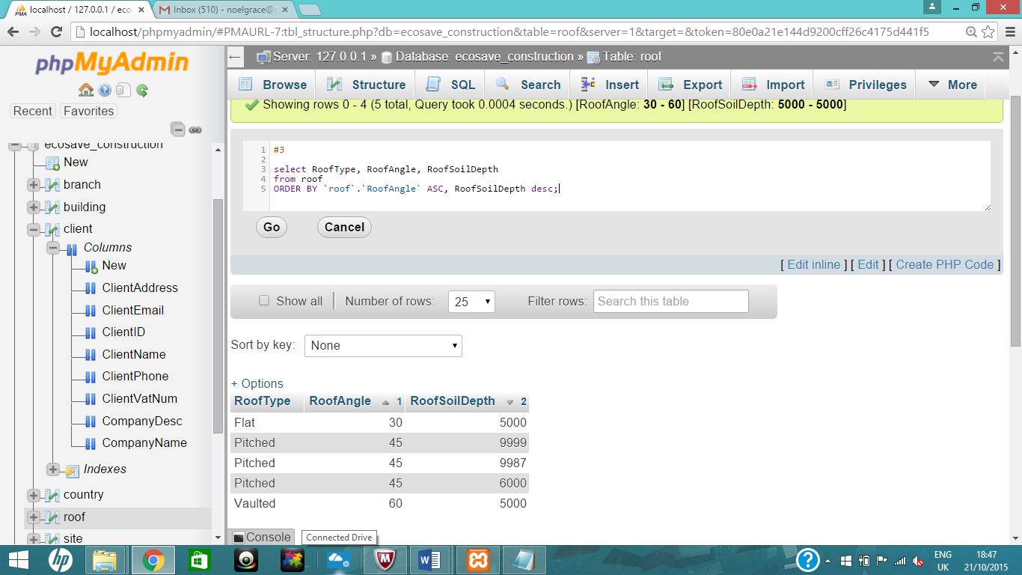

#4 showing part 2 (RoofSoilDepth desc)

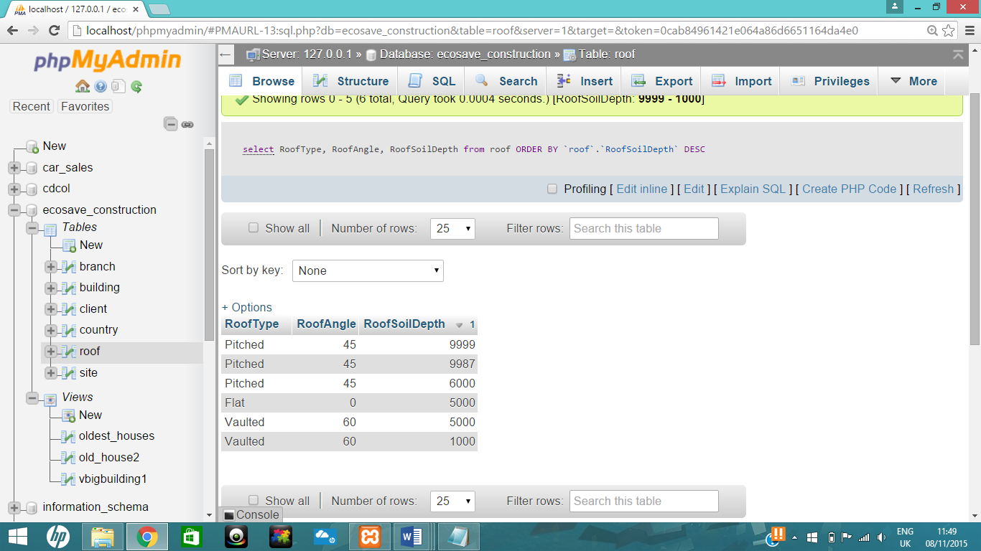

#5

select SiteID as 'SiteNo', SiteAddress as 'Address', S_BranchID as 'BranchID'

from ecosave_construction.site;

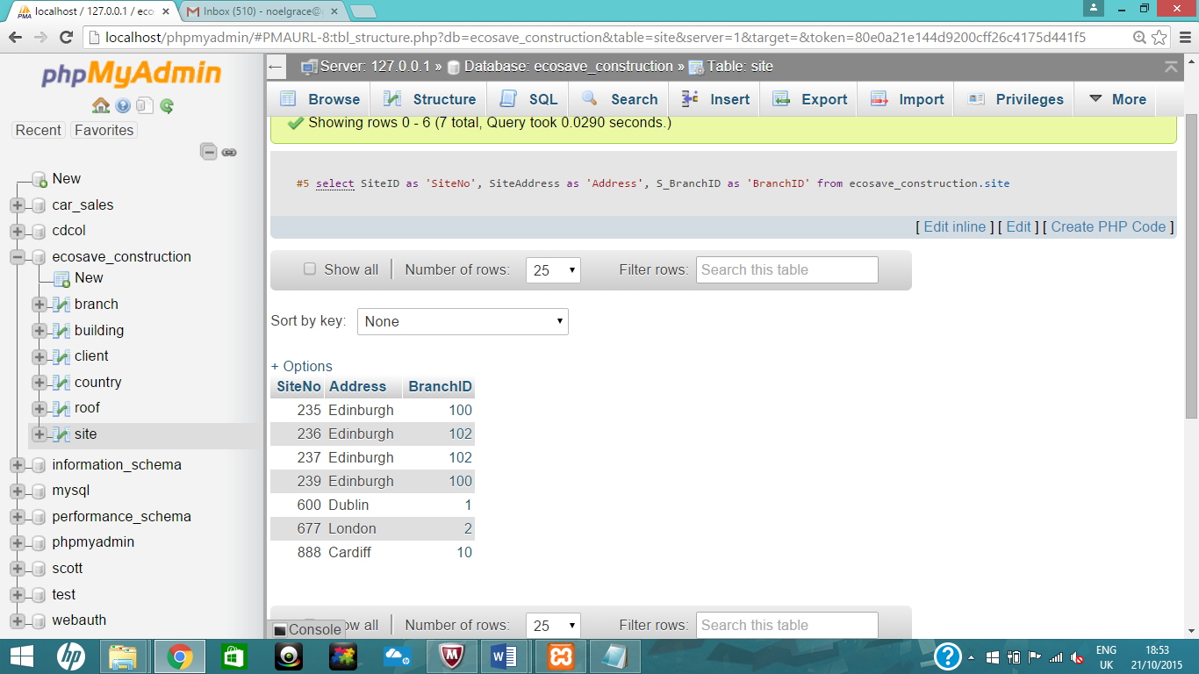

#6

select distinct RoofType from roof;

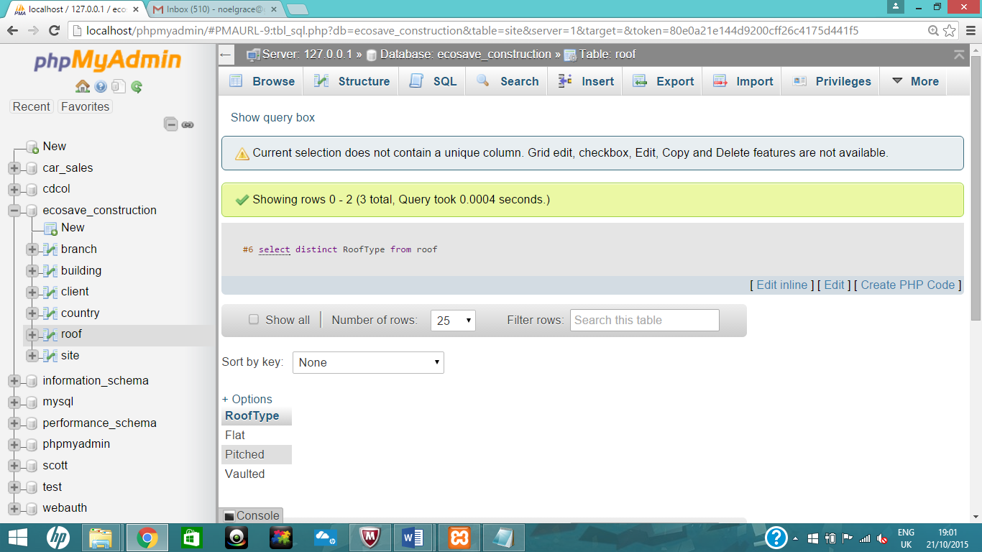

#7

select RoofType, max(RoofSoilDepth)

from roof

group by roofType;

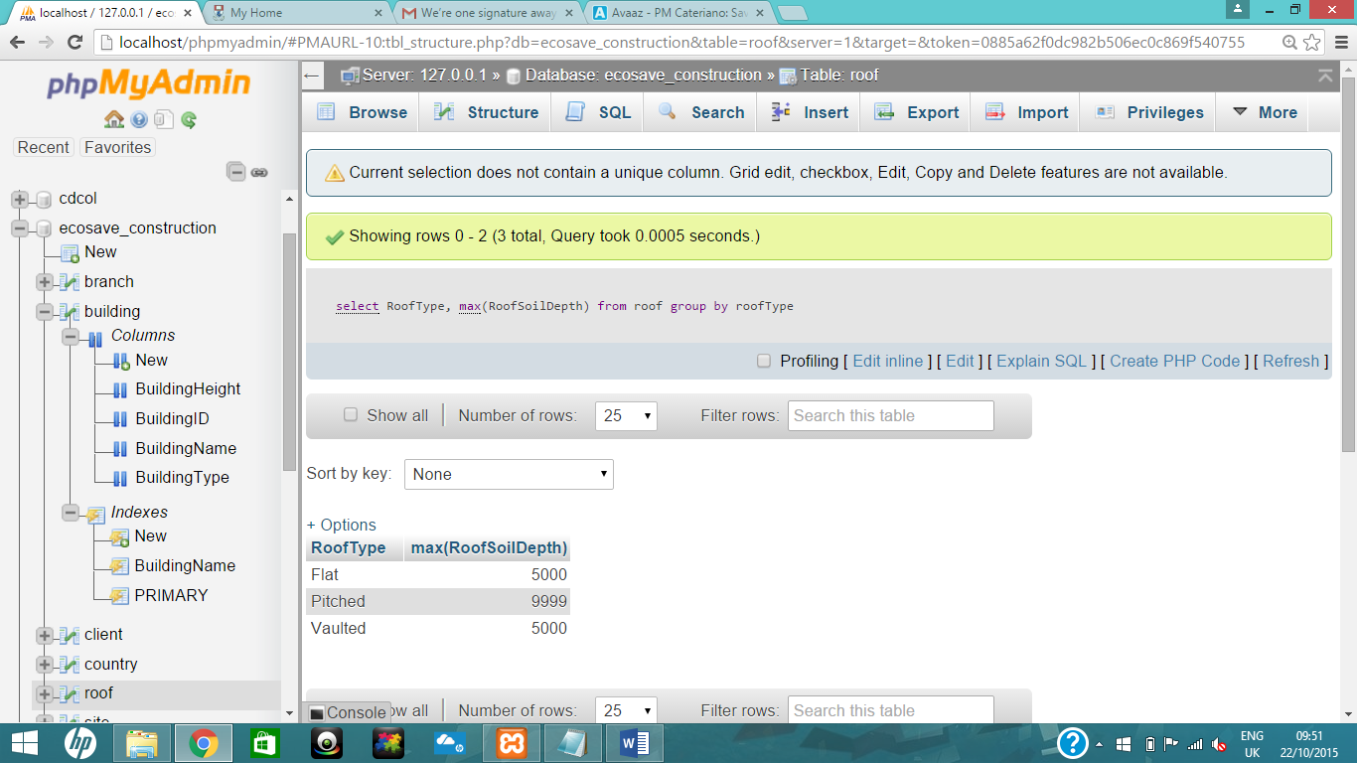

#8

select SiteAddress, S_BranchID, S_RoofID

from site

having Siteaddress <>'Edinburgh';

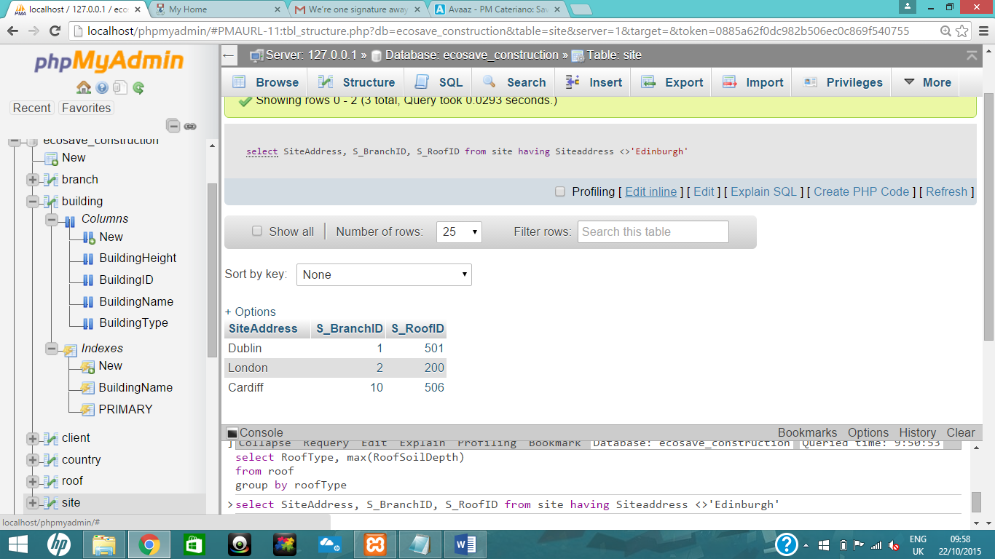

## Write 4 join/sub query statements to query the data that you have included in your tables

#1

Insert into Roof values (525, "Vaulted", 60, 1000);

INSERT INTO site (SiteID, StartDate, SiteAddress, EndDate, S_BranchID, S_BuildingID, S_ClientID) VALUES (999, '1982-12-01', 'London', '2015-12-01', 2, 999, 60555)

#1 right join

SELECT Site.SiteAddress, Roof.RoofType

FROM Site

right JOIN Roof

ON Site.S_RoofID = Roof.RoofID;

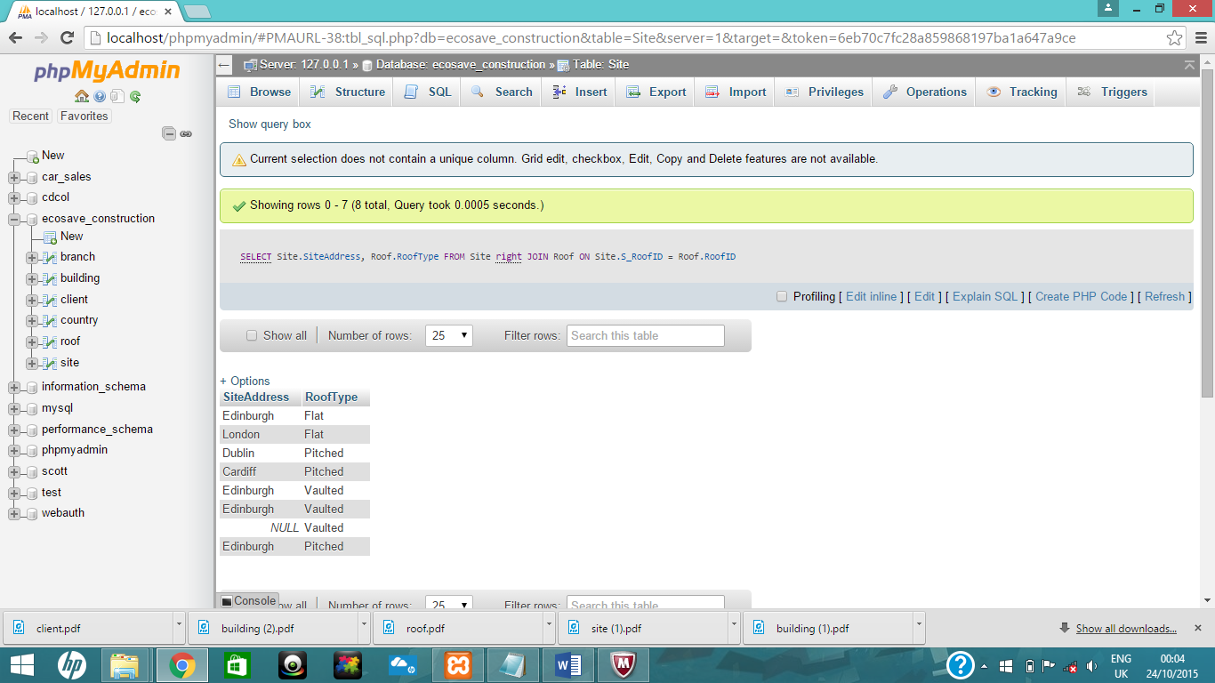

#1 left join

SELECT Site.SiteAddress, Roof.RoofType

FROM Site

left JOIN Roof

ON Site.S_RoofID = Roof.RoofID;

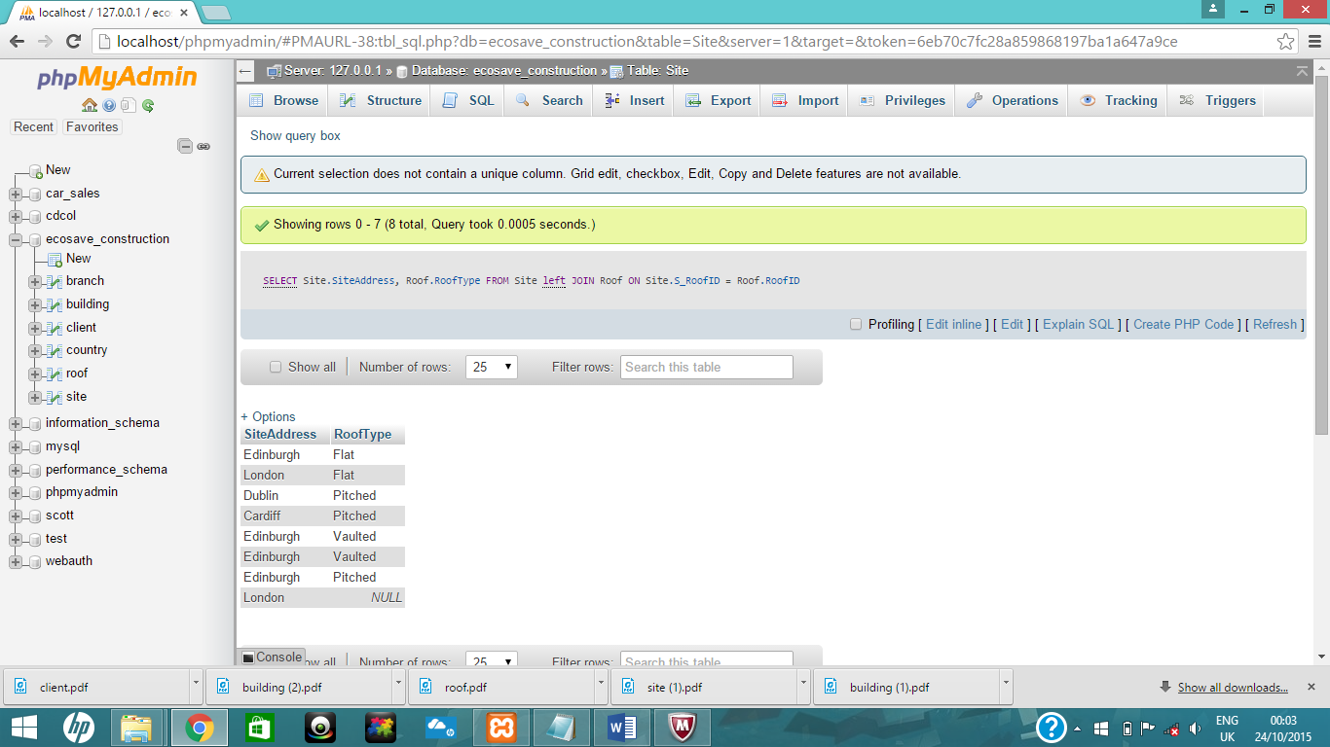

#2 union

SELECT Site.SiteAddress, Roof.RoofType

FROM Site

left JOIN Roof

ON Site.S_RoofID = Roof.RoofID

UNION

SELECT Site.SiteAddress, Roof.RoofType

FROM Site

right JOIN Roof

ON Site.S_RoofID = Roof.RoofID;

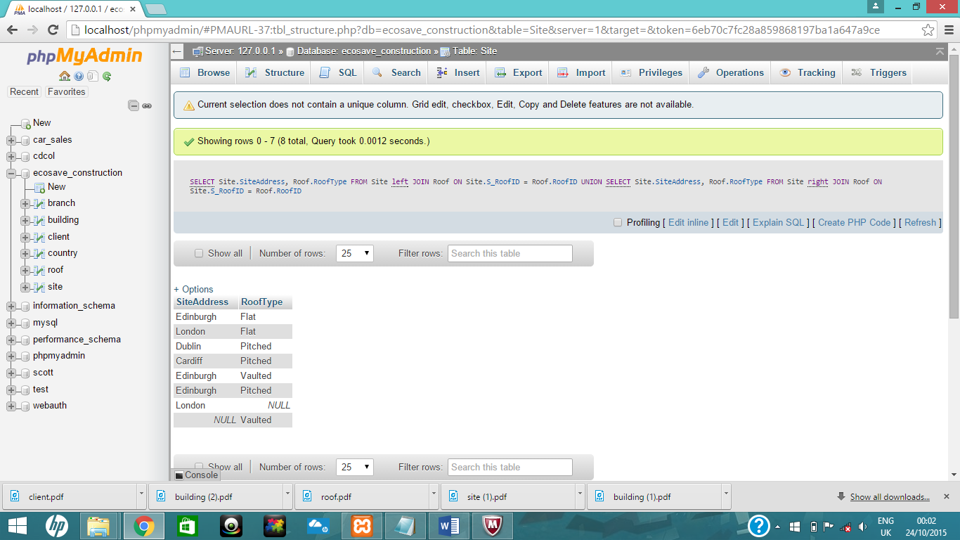

#3 Sub query

SELECT CountryCapital

from country

where CountryID in (Select BranchID

from Branch

where BranchEmail='Dublin@ecosave.com');

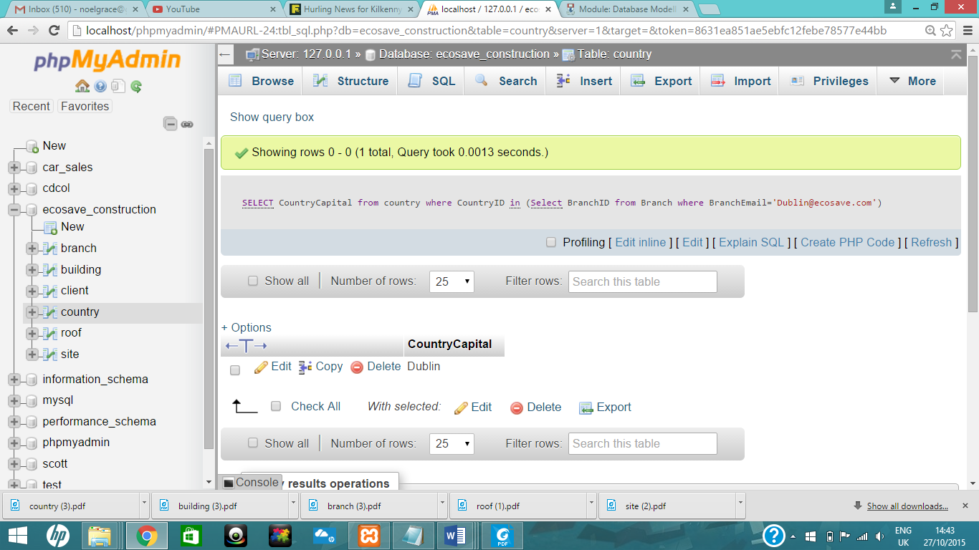

#4 Join

Select ClientName, ClientAddress, BranchName, CountryName

from EcoSave_Construction.Client

join EcoSave_Construction.Site on s_ClientID=ClientID

join EcoSave_Construction.branch on s_BranchID=BranchID

join EcoSave_Construction.Country on b_CountryID=CountryID

where ClientAddress like 'D%'

and CountryName='ireland';

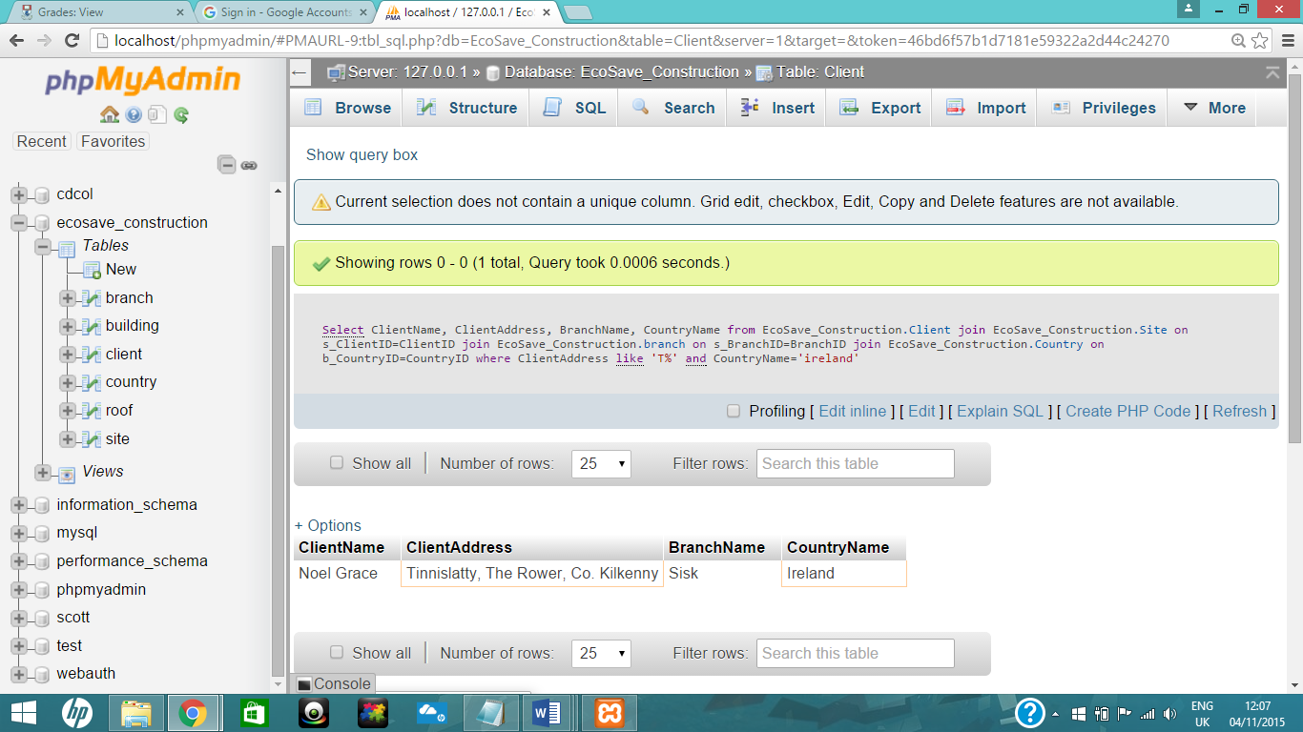

## Write 3 views to query the data in the tables.

#1 Views

CREATE VIEW VBigBuilding1

AS

SELECT BuildingType

FROM Building

WHERE BuildingHeight > 1000;

#1 View of VBigBuilding1

SELECT * FROM `vbigbuilding1`;

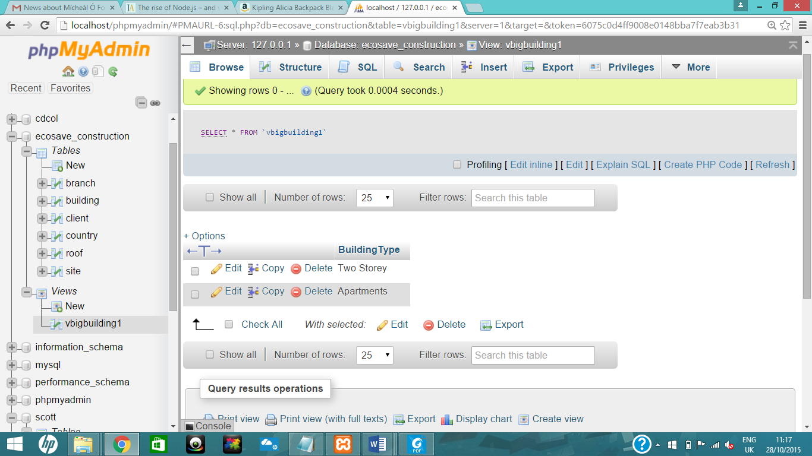

#2

CREATE VIEW Old_House2

AS

SELECT BuildingName

FROM Building

WHERE BuildingName like 'G%' and BuildingType='TownHouse';

#2 select

[SELECT](http://localhost/phpmyadmin/url.php?url=http://dev.mysql.com/doc/refman/5.5/en/select.html) * FROM `old_house2`;

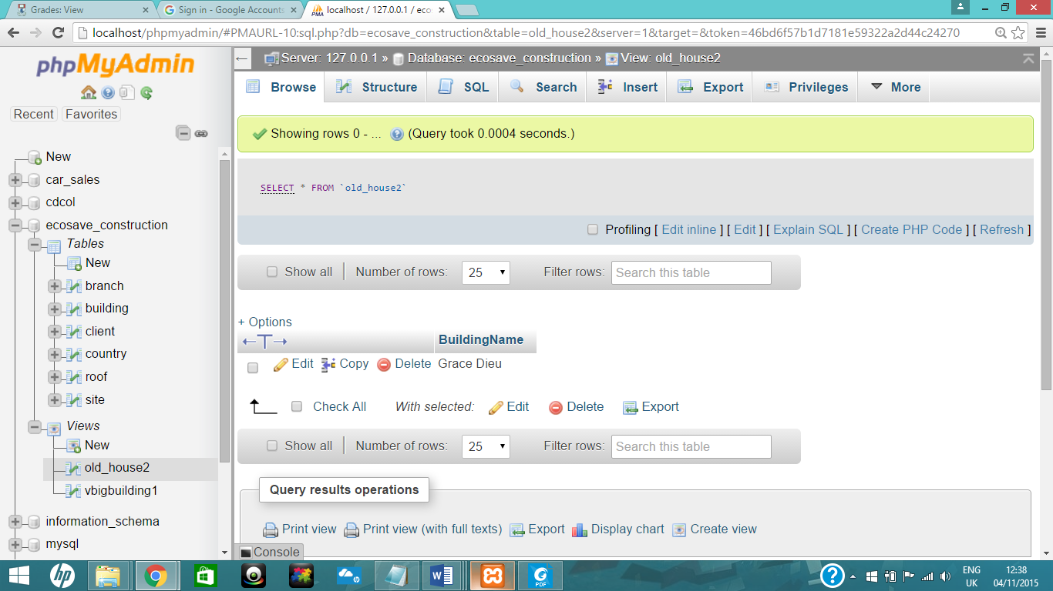

#3

CREATE VIEW Oldest_Houses

AS

SELECT distinct building.buildingName, site.s_BuildingID

FROM building

INNER JOIN site

ON building.buildingID = Site.S_BuildingID

ORDER BY `buildingName` DESC;

#3 Select

SELECT * FROM `oldest_houses`;

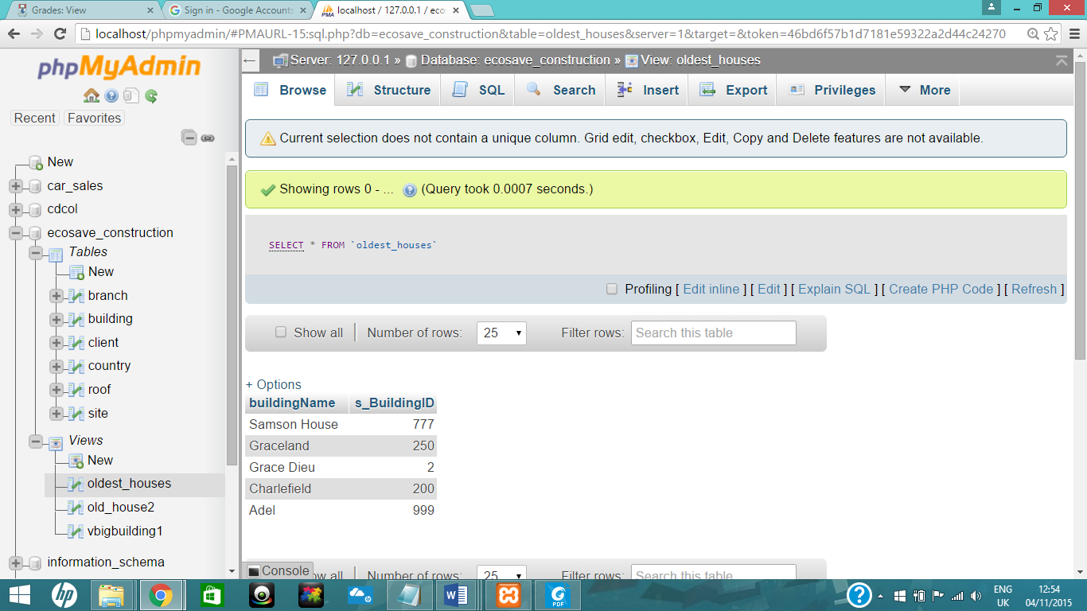

## Write an SQL command to do each of the following

## Alter table

## Delete records from table

## Update data in table

## Drop column

## #1 ALTER TABLE

ALTER TABLE Building

ADD COLUMN Owner varchar (15) DEFAULT 'Noel Grace'

AFTER BuildingName;

#1 select TABLE

SELECT * FROM `building`;

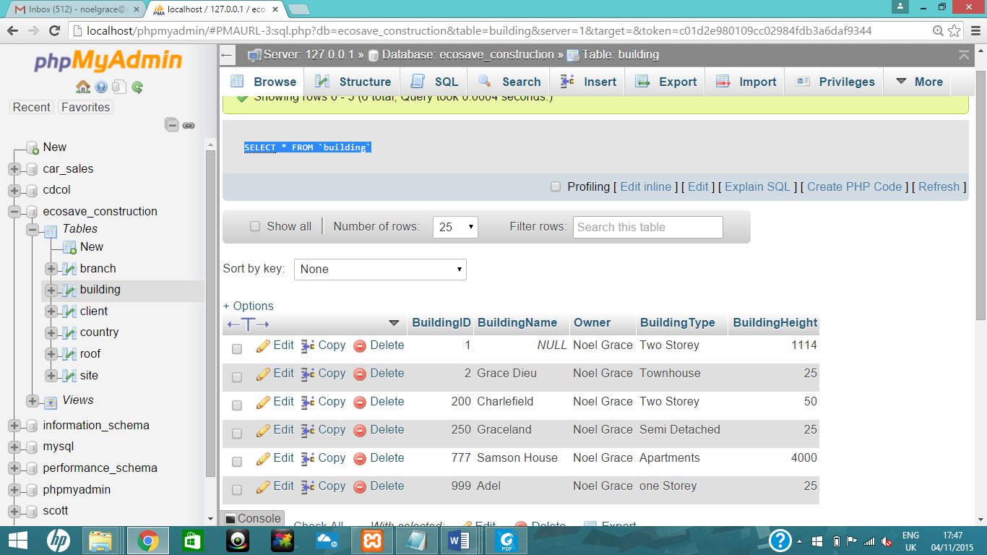

## #2 Delete records from table

ALTER TABLE Site DROP FOREIGN KEY FK_RoofID;

ALTER TABLE Site

ADD CONSTRAINT FK_RoofID

FOREIGN KEY(S_RoofID) REFERENCES Roof (RoofID)

ON DELETE CASCADE ON UPDATE CASCADE;

DELETE FROM roof

WHERE RoofID=501;

SELECT * FROM `roof`;

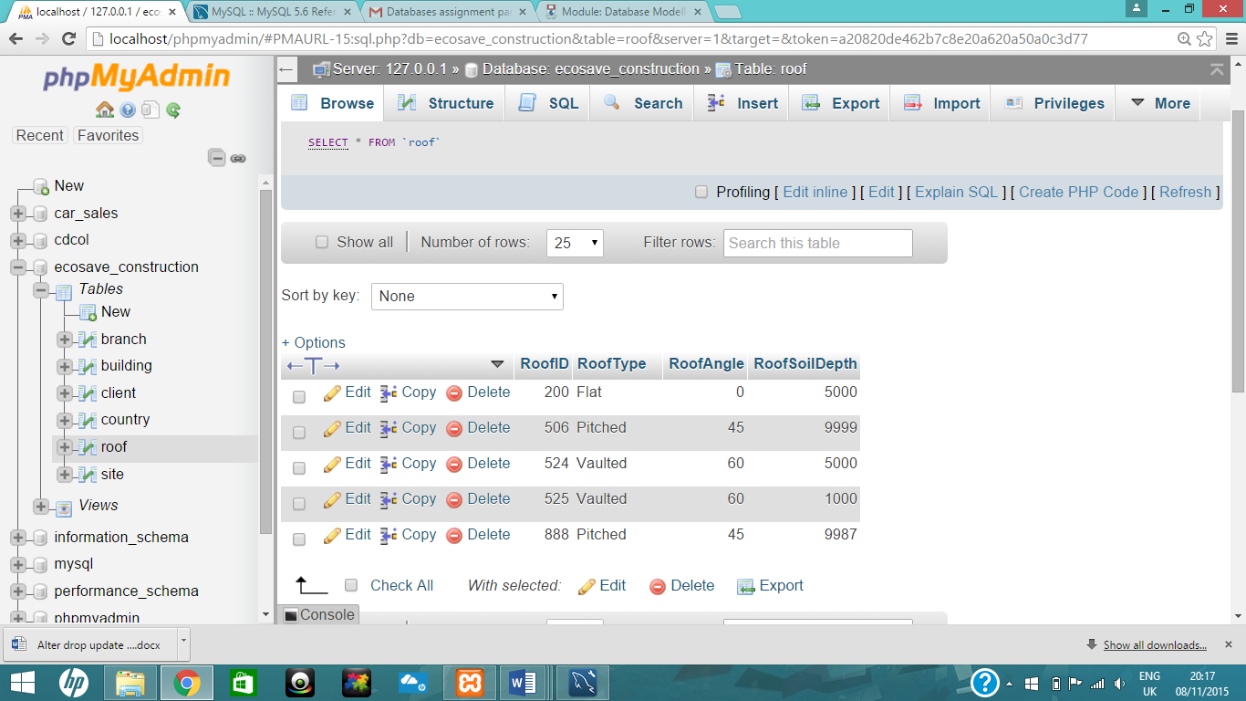

#3 Update data in table

update roof set roofAngle=0 where RoofType='flat';

SELECT * FROM `roof`;

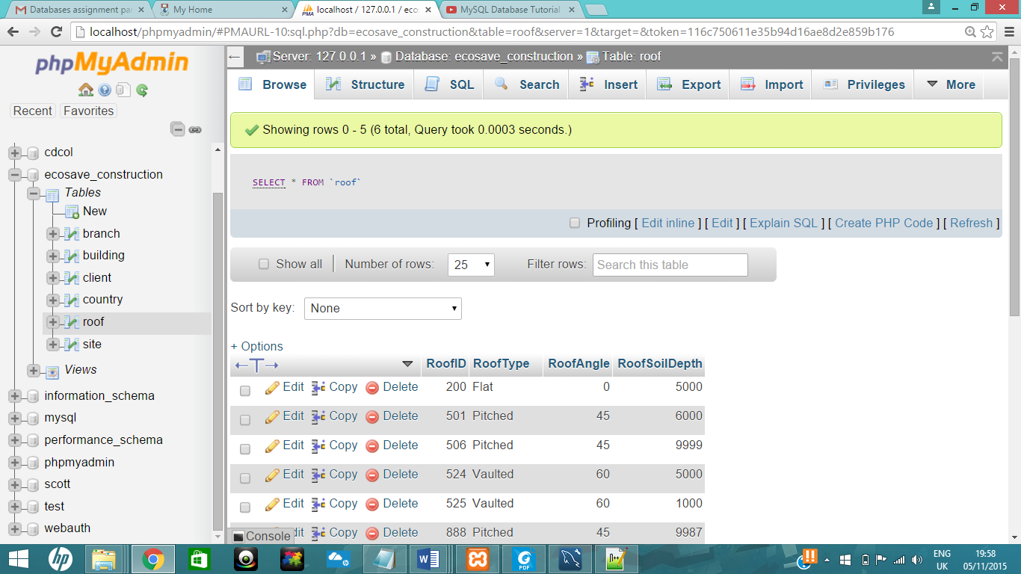

## #4 Drop column

ALTER TABLE Building

DROP COLUMN Owner;

#4 select TABLE

SELECT * FROM `building`;

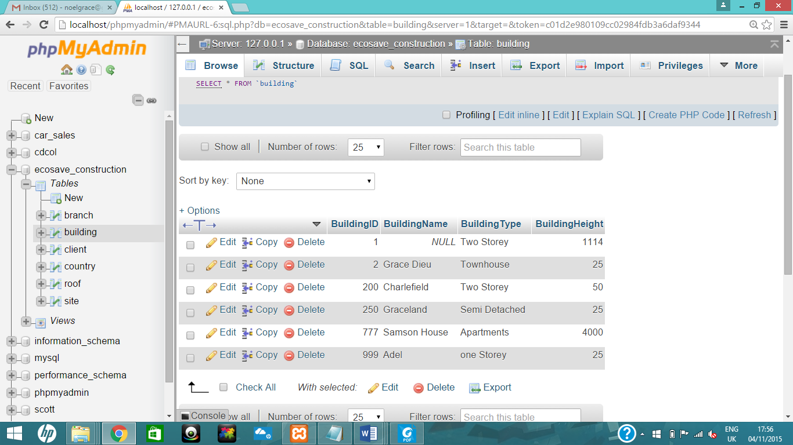

# Part C

## Write the code that would allow you to set up 2 users and manager on your database

CREATE USER Receptionist@localhost

IDENTIFIED BY 'Receptionist';

CREATE USER Supervisor@localhost

IDENTIFIED BY 'password';

CREATE USER manager@' %'

IDENTIFIED BY ' password2';

# Receptionist, manager & supervisor users

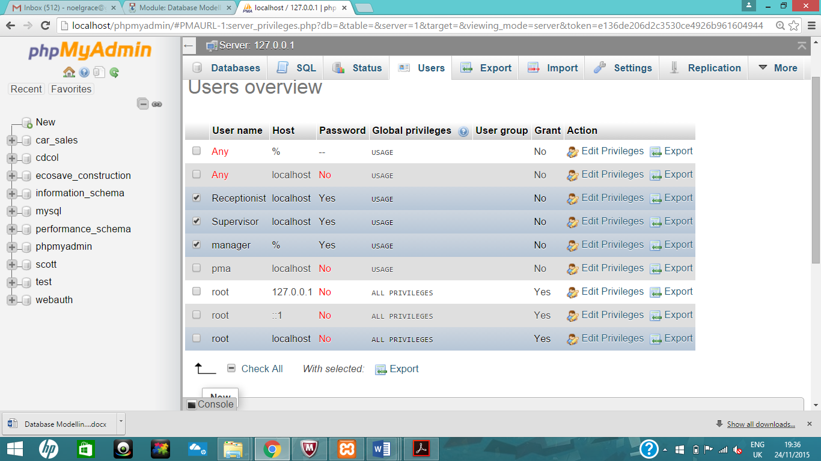

## Grant the manager all privileges to all parts of the database

# grant all on database to manager

GRANT ALL ON ecosave_construction.*

TO manager@’ %’ WITH GRANT OPTION;

#branch table

## 

# building

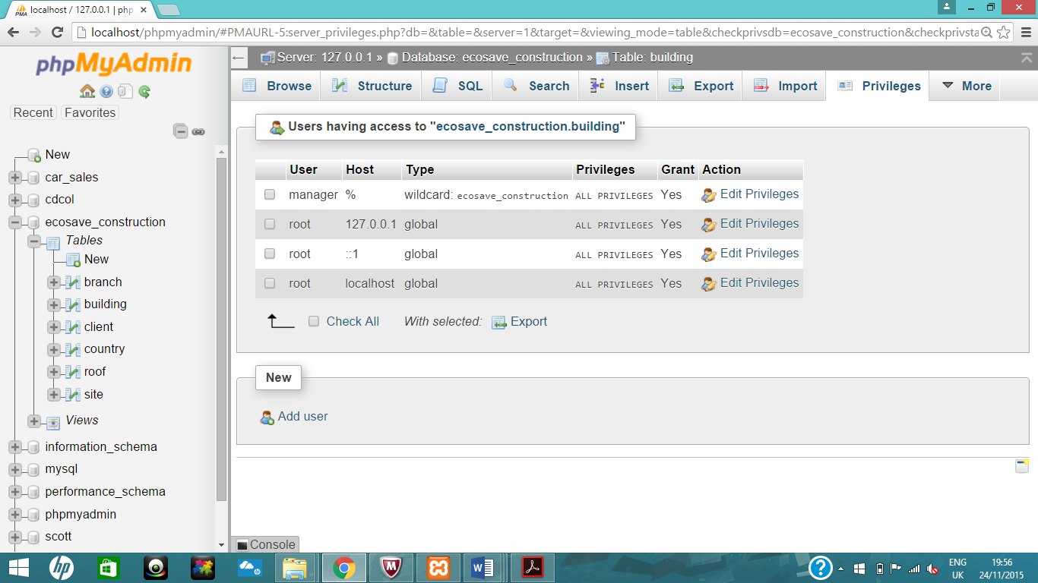

#client

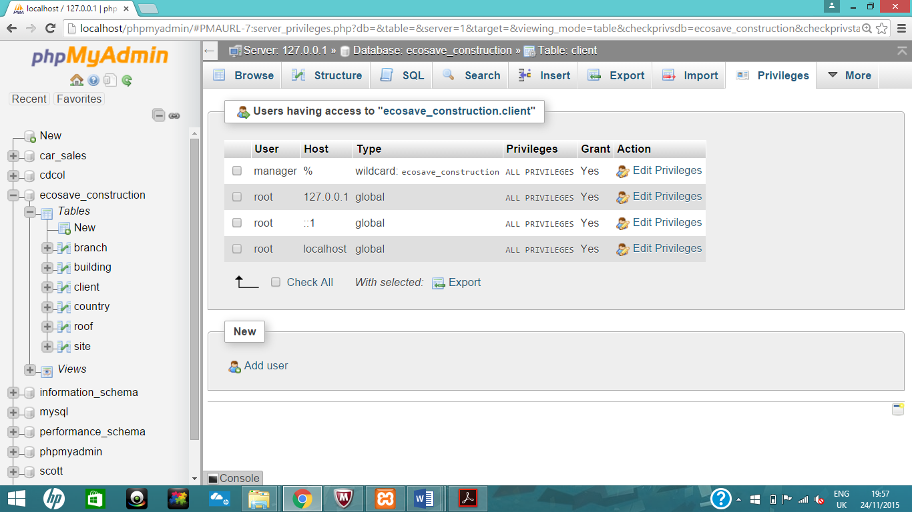

#Country

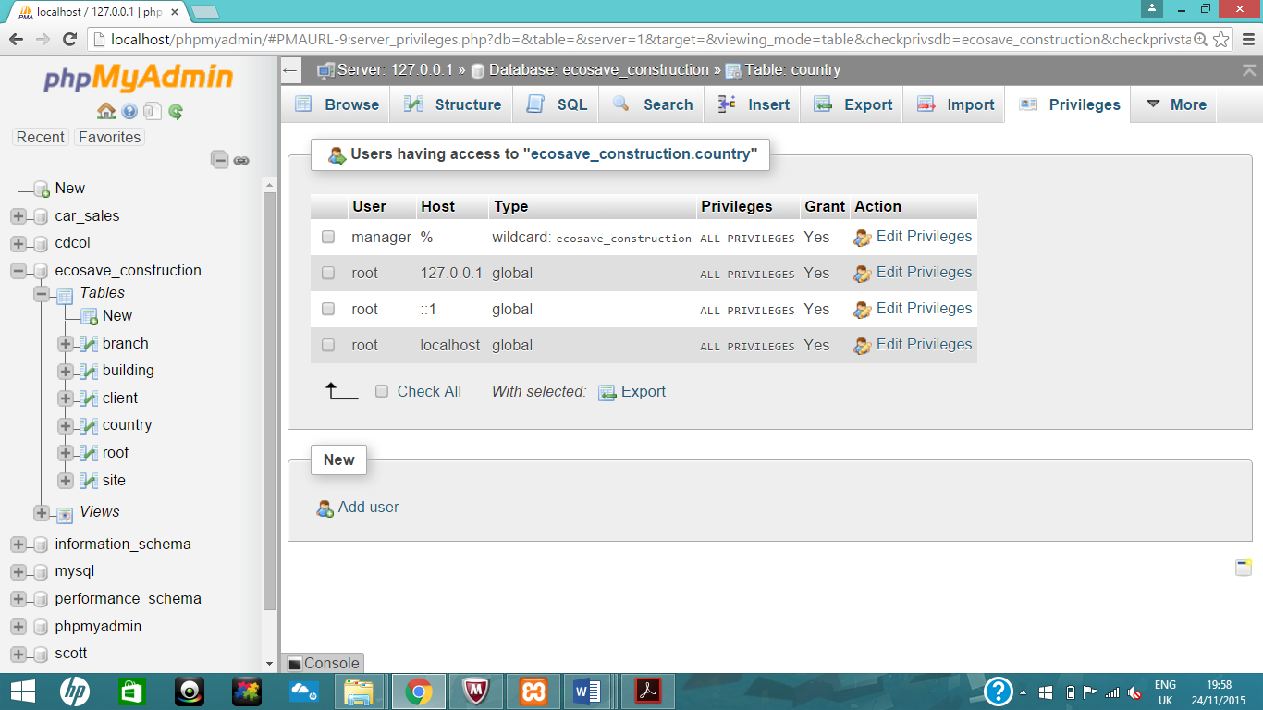

#Roof

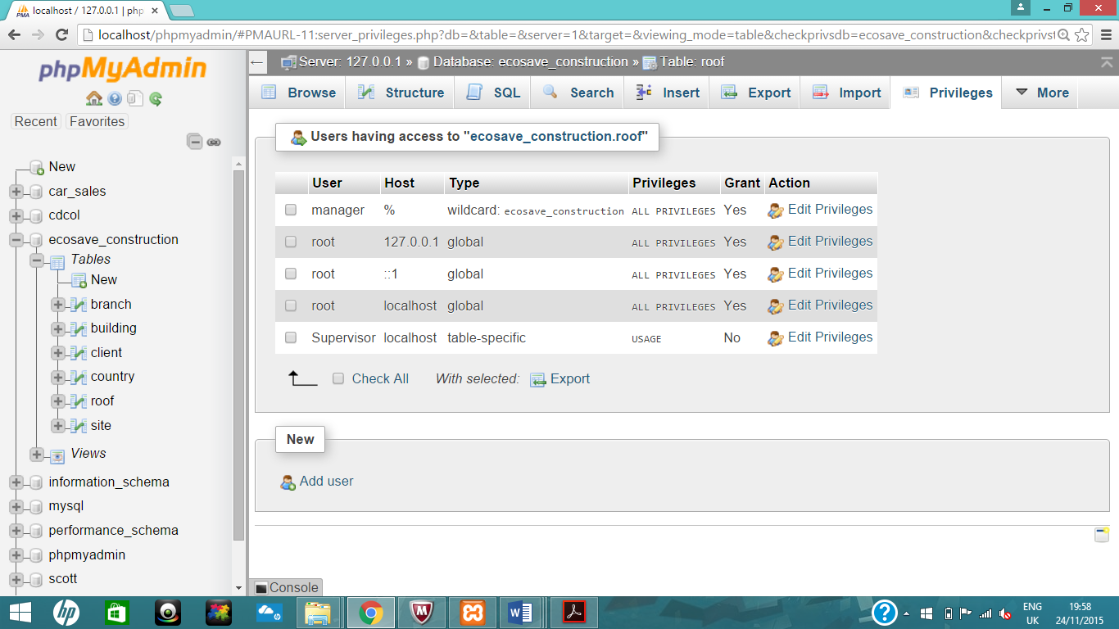

#Site

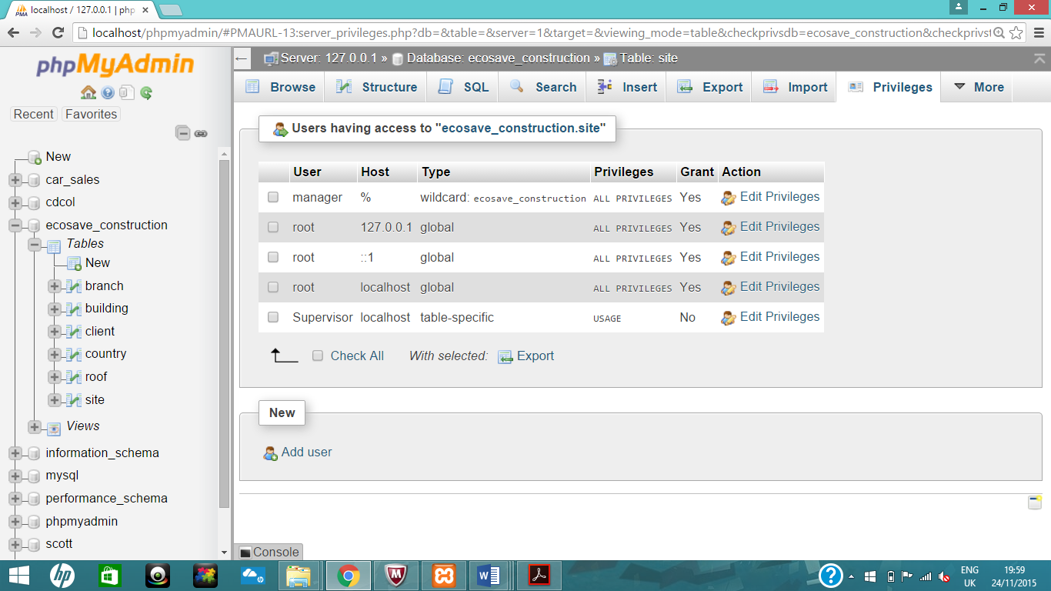

# view oldest_houses

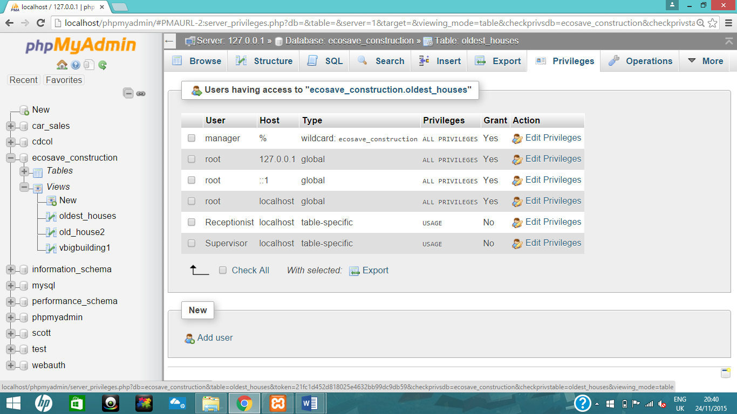

# view old_house2

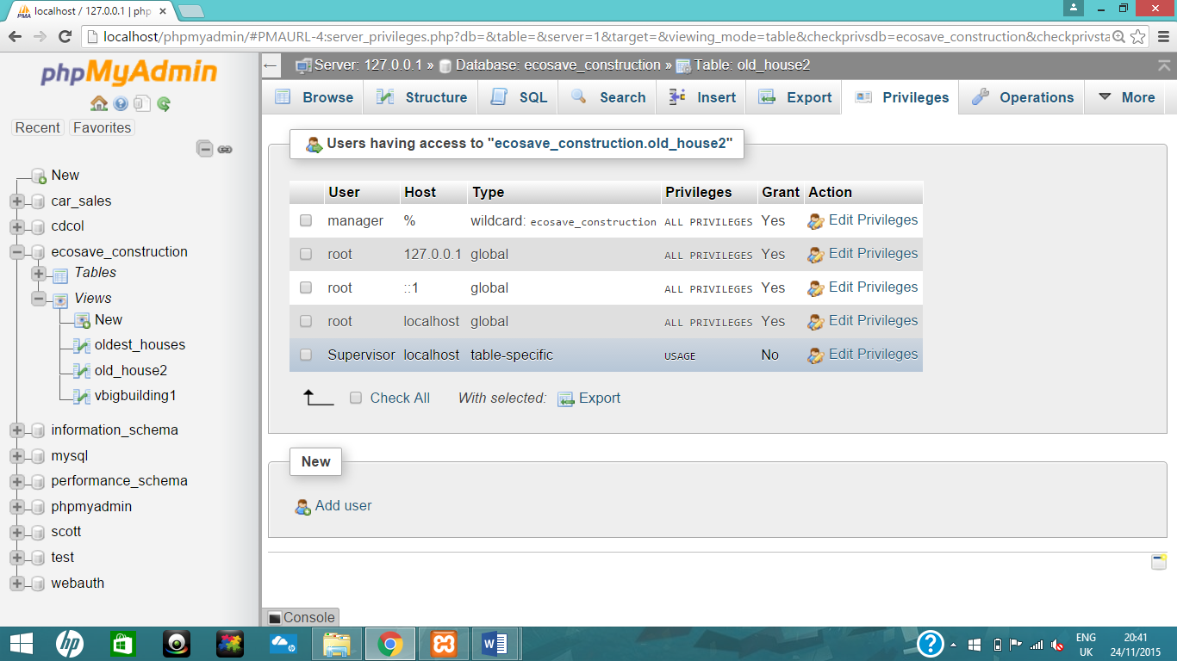

# view vbigbuilding1

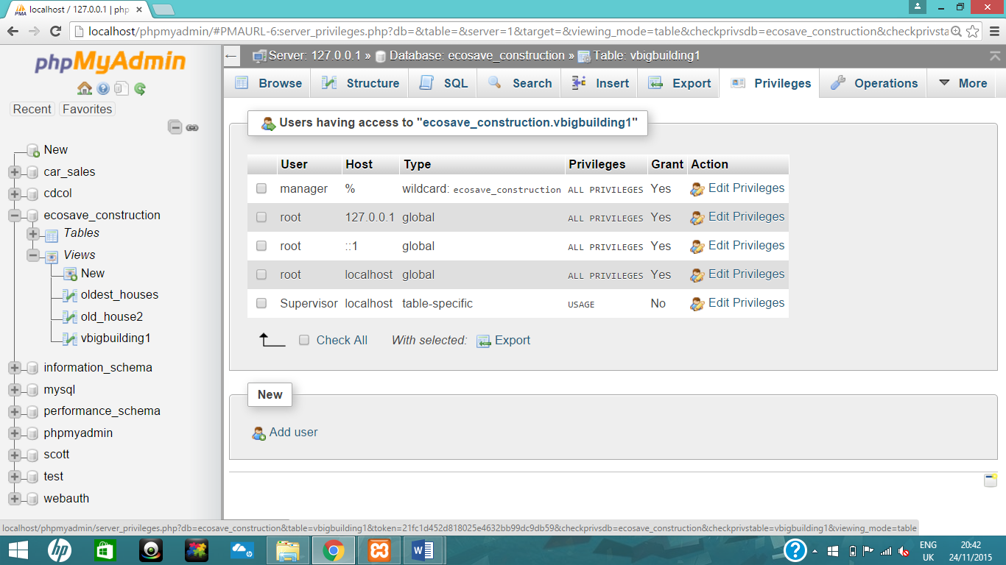

## Grant the user select, update and insert privileges but not delete on certain tables or views.

# grant

GRANT SELECT

ON ecosave_construction.branch

TO Receptionist@localhost;

#branch table

## 

#grant on a particular views and tables

GRANT SELECT

ON ecosave_construction.oldest_houses

TO Receptionist@localhost;

GRANT SELECT

ON ecosave_construction.oldest_houses

TO Supervisor@localhost;

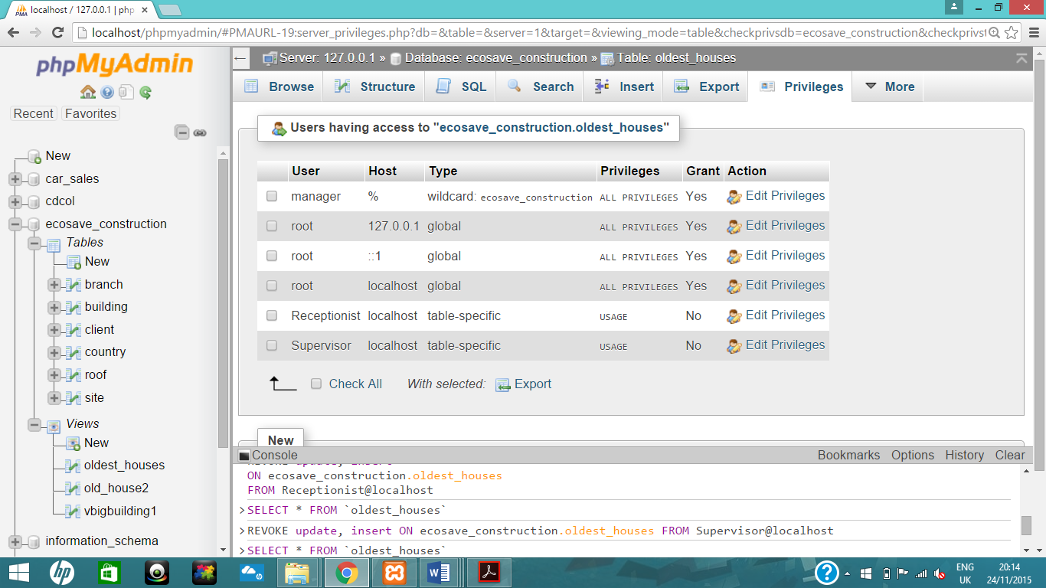

GRANT SELECT

ON ecosave_construction.old_house2

TO Supervisor@localhost;

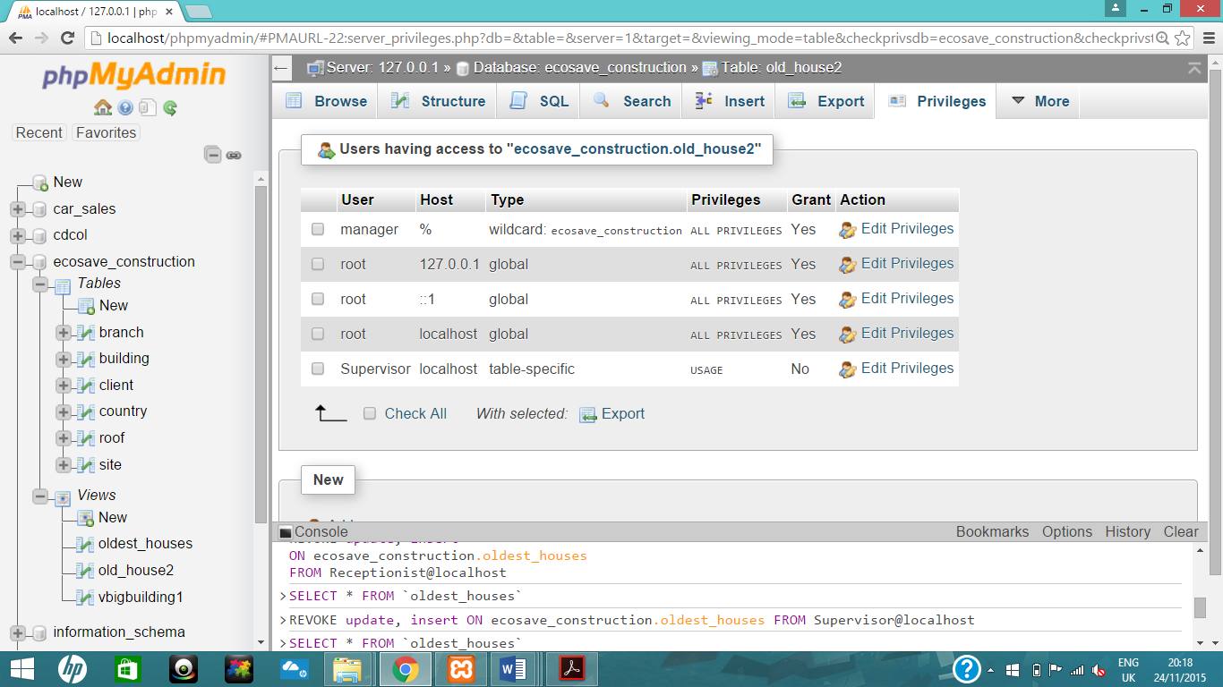

GRANT SELECT

ON ecosave_construction.vbigbuilding1

TO Supervisor@localhost;

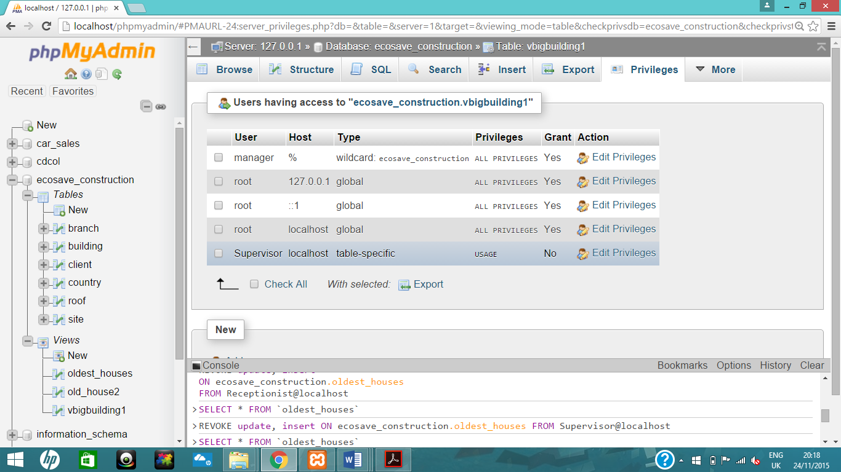

GRANT SELECT, update, insert

ON ecosave_construction.site

TO Supervisor@localhost;

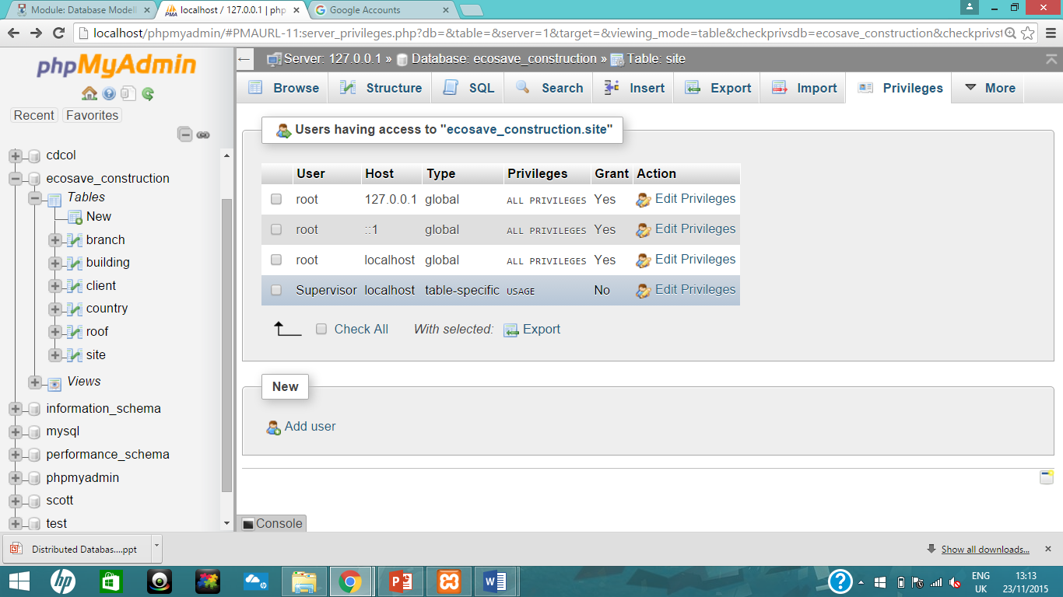

GRANT SELECT, update, insert

ON ecosave_construction.roof

TO Supervisor@localhost;

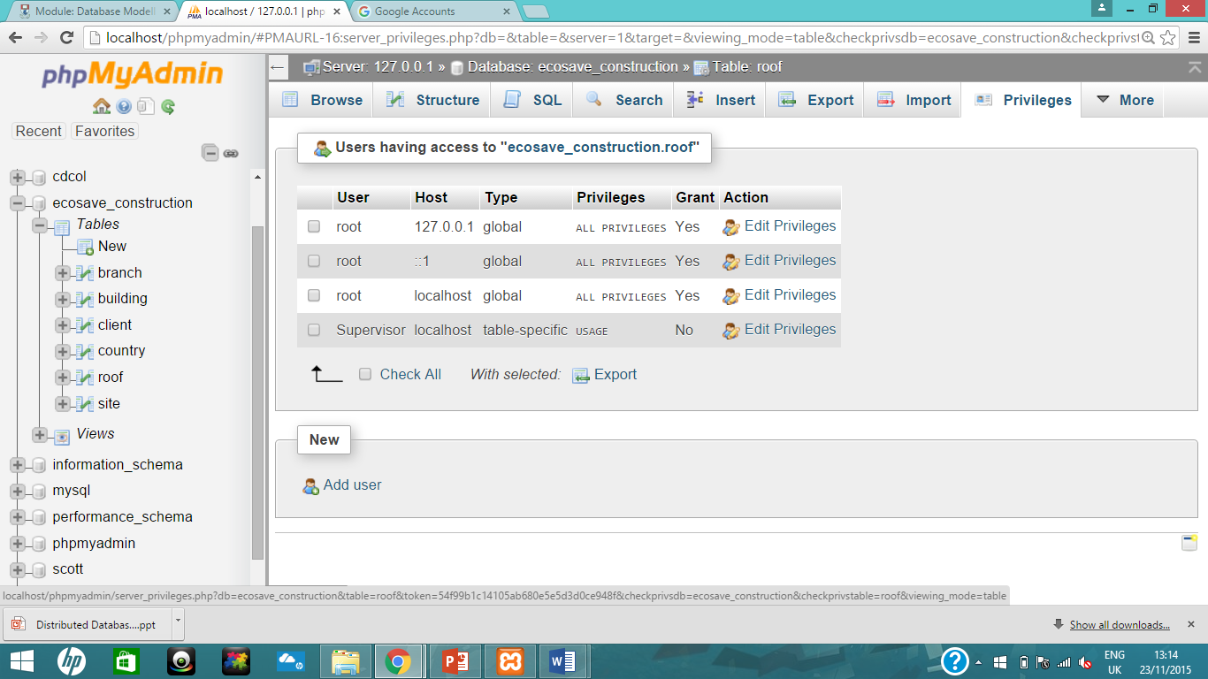

# revoke

revoke insert

ON ecosave_construction.site

from Supervisor@localhost;

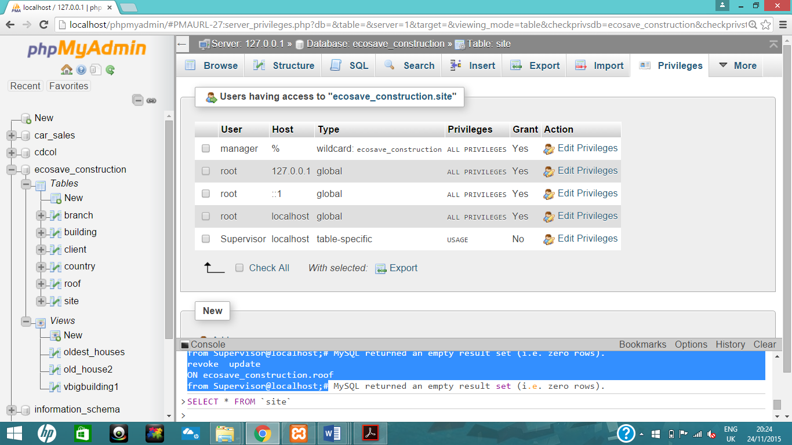

revoke update

ON ecosave_construction.roof

from Supervisor@localhost;

